Lesson 10: Sequences and Series

10.1 Sequence

Definition 10.1 Sequence

A sequence or progression is a list of objects, events or numbers in a definite order of occurrence. Each member of a sequence is called a term. A sequence is said to be finite if it contains finite number of terms. An infinite sequence is one having infinite number of terms, thus, the last term is not indicated. The notation , a_{n}, represents the nth term or the general term of the sequence.

Example 10.1 The following represent a sequence:

- 2, 4, 6, 8 c) 1, 5, 9, 13, 17, 21,…
- 1, 3, 9, 27, … d) ½ , 1, 2, 4,…

10.2 Arithmetic Sequence

Definition 10.2.1 Arithmetic Sequence

An arithmetic sequence is a sequence in which the difference between two successive terms is constant. This difference , d, is called the common difference.

Remarks: For any arithmetic sequence in which 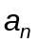is the general term, 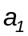 is the first term, and n is a positive integer:
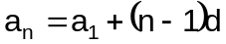

The first and last terms of the sequence are called arithmetic extremes. The terms in between are called arithmetic means. The arithmetic mean between 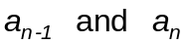 is defined by

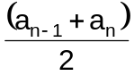
The arithmetic mean of n terms is

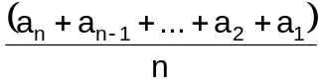
Example 10.2.1.1 Given the sequence 1, -4, -9, …, list the next three terms and write a formula for the nth term .
ans. -14, -19, -24
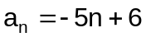

Example 10.2.1.2 Insert three arithmetic means between 6 and -6.
ans. 3, 0, -3

Example 10.2.1.3 In the arithmetic sequence –9, -2, 5, …, which term is 131?
ans. n = 21

Example 10.2.1.4 The last term of an arithmetic sequence is 207, the common difference is 3, and the number of terms is 14. What is the first term of the sequence?
ans. 168

Example 10.2.1.5 The fifth term of an arithmetic sequence is 3 and the fifteenth term is 8. What is the general term of the sequence?
ans. 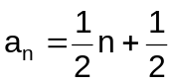

Definition 10.2.2 Sum of the First n Terms of an Arithmetic Sequence

The sum of the first n terms of an arithmetic sequence is given by:

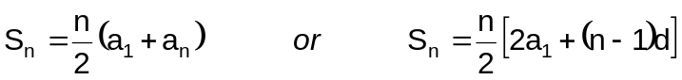

Example 10.2.2.1 Find the sum of the positive even integers up to and including 350.

Example 10.2.2.2 For an arithmetic series with 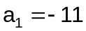, 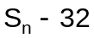 and fourth term is -5, find d and n.

Example 10.2.2.3 The balcony of a theater has 12 rows of seats. The last row contains 8 seats, and each of the other rows contains one more seat than the row behind it. How many seats are there in the balcony?

Example 10.2.2.4 The sum of the progression 5, 8, 11, 14, … is 1025. How many terms are there?
10.3 Harmonic Sequence

Definition 10.3.1 Harmonic Sequence

Harmonic sequence is a sequence formed by the reciprocals of the terms of an arithmetic sequence. The terms between any two terms of a harmonic sequence are called harmonic means. To find the nth term of a harmonic sequence , first write the corresponding arithmetic sequence. Second, determine the nth term of the arithmetic sequence. Lastly, take its reciprocal.

Example 10.3.1.1 What is the ninth of the harmonic progression 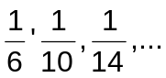?

Example 10.3.1.2 What is the value of k so that the terms 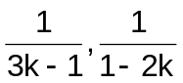 and 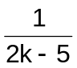 form a harmonic sequence?

10.4 Geometric Sequence

Definition 10.4.1 Geometric Sequence

A geometric sequence is a sequence in which the ratio of any two consecutive terms is constant. This constant is called the common ratio, denoted by r.

The nth term of a geometric sequence is given by

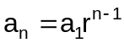

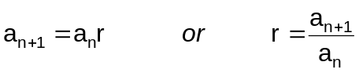

A single geometric mean between two numbers is called the geometric mean, or the mean proportional given by

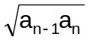

Example 10.4.1.1 The third term of a geometric sequence is 32 and the fifth term is 128. Find the first term and the common ratio.

Example 10.4.1.2 What is the mean proportional between 15 and 60?

Example 10.4.1.3 The fourth term of a geometric sequence is –10 and the sixth term is -40. What is the ninth term of the sequence?

Example 10.4.1.3 KT Airlines’ passenger load has been increasing by 12 % annually. In 2000 they carried 20,500 passengers. How many passengers should they expect to carry in 2010?

Definition 10.4.2 Sum of the First nth terms of a Finite Geometric Sequence

The sum of the first nth terms of a finite geometric sequence is given by

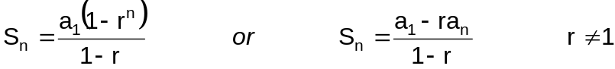

Example 10.4.2.1 If 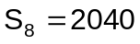 and the common ratio is 2, what is 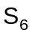 ?

Example 10.4.2.2 A piece of paper is 0.05 in thick. Each time the paper is folded into half, the thickness is doubled. If the paper was folded 12 times, how thick in feet the folded paper will be?

Definition 10.4.3 Infinite Geometric Series

The sum of a convergent infinite geometric series is given by

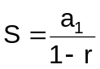 for 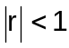

Example 10.4.3.1 Find the sum of the infinite geometric progression 36, 24, 16, …

Example 10.4.3.2 A rubber ball rebounds  of its height. If it is initially 30 ft high, what total vertical distance does it travel before coming to rest?

